LIST OF FIGURES
Figure 4.1: Architecture of the Proposed System in Terms of Tiers
Figure 4.2: Entity-Relationship Diagram of the Database
Figure 4.3: Interface Design for the Administrator Sign-In Screen
Figure 4.4: Interface Design for the Administrator Dashboard
Figure 4.5: Interface Design for User Registration and Card Issue
Figure 4.6: Interface Design for the Attendance Terminal and Its Two Outcomes
Figure 4.7: Interface Design for Session Management
Figure 4.8: Interface Design for Attendance Records
Figure 4.9: Flowchart of User Registration and Card Issue
Figure 4.10: Flowchart of the Attendance Marking Process
Figure 4.11: Sequence Diagram for a Card Tap
LIST OF TABLES
Table 4.1: Development Tools and Their Purpose
Table 4.2: Structure of the users Table
Table 4.3: Structure of the nfc_cards Table
Table 4.4: Structure of the sessions Table
Table 4.5: Structure of the attendance_records Table
Table 4.6: Third-Party Libraries and Services
Table B.1: Test Plan and Expected Results

CHAPTER FOUR
SYSTEM DESIGN AND IMPLEMENTATION
4.1 Objective of Design
The objective of the design is to convert the analysis of Chapter Three into a specification for a working Smart Attendance System using Near Field Communication. The design settles the structure the system will take, the way its data is organised, the interfaces through which it is operated, and the procedures by which a card is issued and an attendance record is created.
The specific objectives of the design are as follows:
• To hold users, issued cards, sessions and attendance records in one database, replacing the paper registers described in Section 3.3.
• To bind each NFC card to exactly one registered user, so that the identity a tap asserts can be resolved without ambiguity.
• To record attendance automatically from a tap, stamping the time, the terminal and the session without any manual entry.
• To make a duplicate record impossible rather than merely unlikely, so that a second tap by the same user in the same session cannot be stored.
• To retain every tap, including those refused, so that attempts at impersonation leave a trace that can be examined.
• To produce attendance reports for a session, a course or a date range without compiling them by hand.
Two matters of scope should be stated at the outset, both following from Section 1.5. The system is presented here as a design and a specification rather than as a deployed installation, because an installation would require NFC readers and issued cards that are outside the means of the study. The interface figures in Section 4.6 are therefore interface designs rather than photographs of a running program, and the results in Appendix B are the outcomes each test is expected to produce when the system is built and exercised.
4.2 System Architecture in Terms of Tiers
The system is designed in three tiers, shown in Figure 4.1. The presentation tier consists of the attendance terminal placed at the venue and the administrator's web console. The application tier holds every rule the system enforces and is the only tier permitted to reach the database. The data tier holds the four tables defined in Section 4.5.
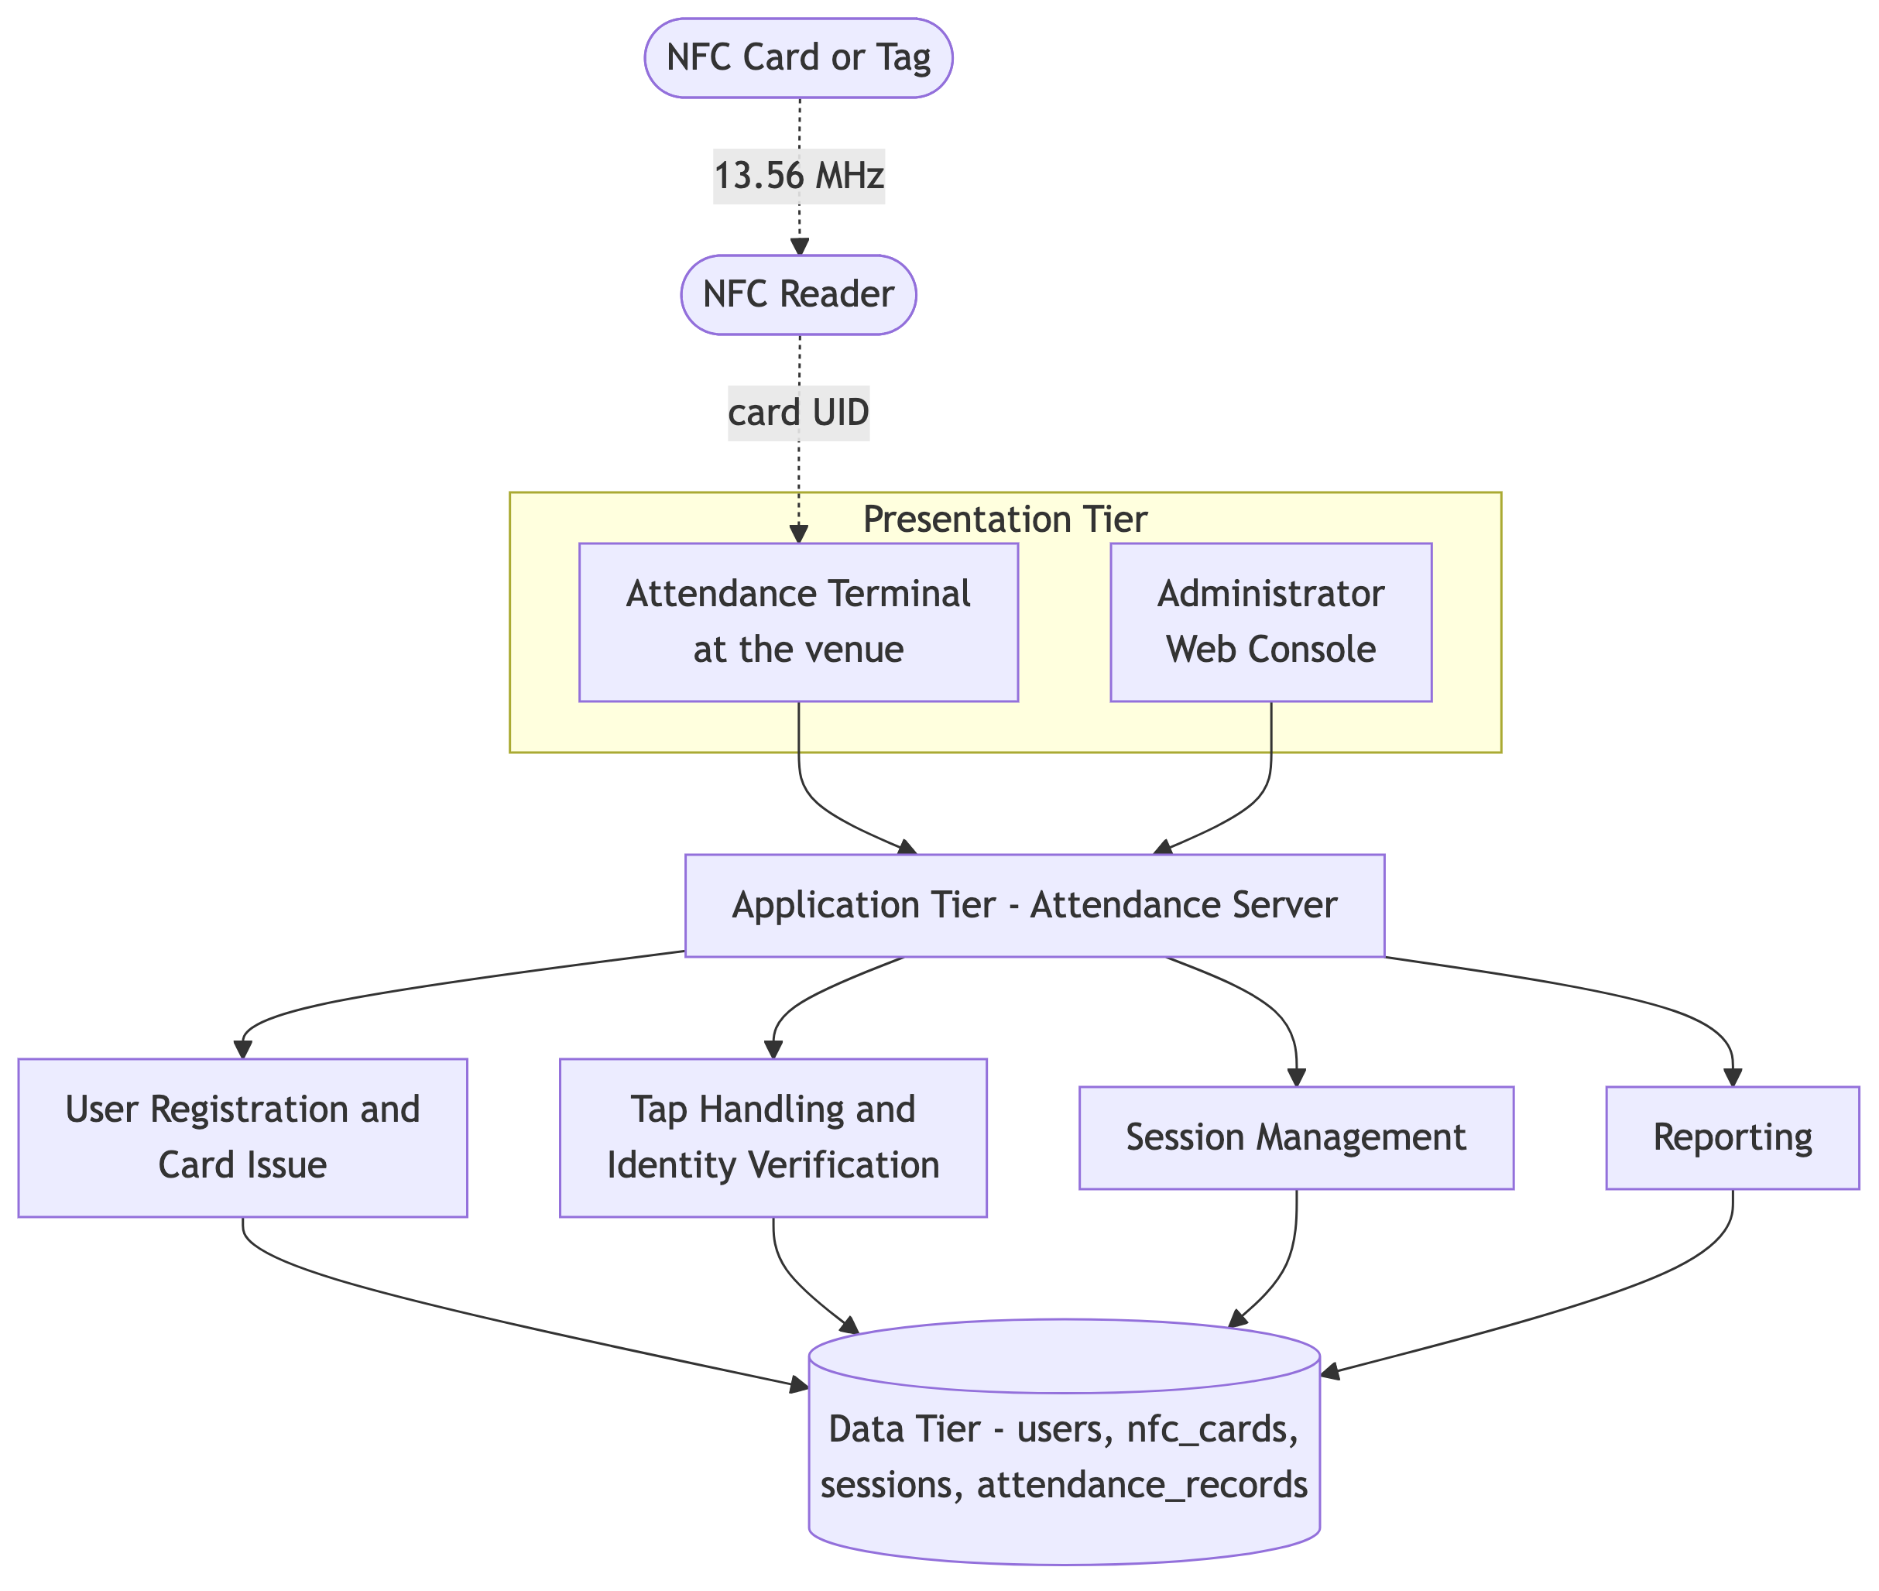
Figure 4.1: Architecture of the Proposed System in Terms of Tiers
The NFC reader and the card itself are shown outside the three tiers because they are field hardware rather than software components. The reader communicates with the card over a distance of a few centimetres at 13.56 MHz, as described in Section 2.1.3, and passes the card's unique identifier to the terminal. Placing every rule in the application tier rather than in the terminal is a deliberate decision: a terminal is a device in a public room and may be tampered with, so it is treated as an input device that reports a tap, not as an authority that decides whether the tap counts.
4.3 Choice of Programming Environment
Python was chosen as the implementation language because mature libraries exist for both contactless reader access and web application development, which keeps the effort on the attendance rules rather than on device drivers. MySQL was chosen for the data tier because the data is strongly relational, in the sense described by Elmasri and Navathe (2016), a user has one card and many attendance records, and because the duplicate rule described in Section 4.4 can be enforced by a constraint in the database itself rather than by code that might be bypassed. Table 4.1 lists the tools.
Table 4.1: Development Tools and Their Purpose
Tool | Purpose
Python 3 | Implementation language for the terminal program and the server.
Flask | Web framework providing the administrator console and the terminal's interface to the server.
MySQL | Relational database holding users, cards, sessions and attendance records.
pyscard / nfcpy | Communication with the NFC reader to obtain the unique identifier of a presented card.
SQLAlchemy | Database access with parameterised statements, preventing injection at the trust boundary.
bcrypt | Hashing of administrator passwords.
HTML, CSS and JavaScript | Presentation of the console and the terminal display.

4.4 Database Structure
The database comprises four tables. Figure 4.2 shows the relationships between them.
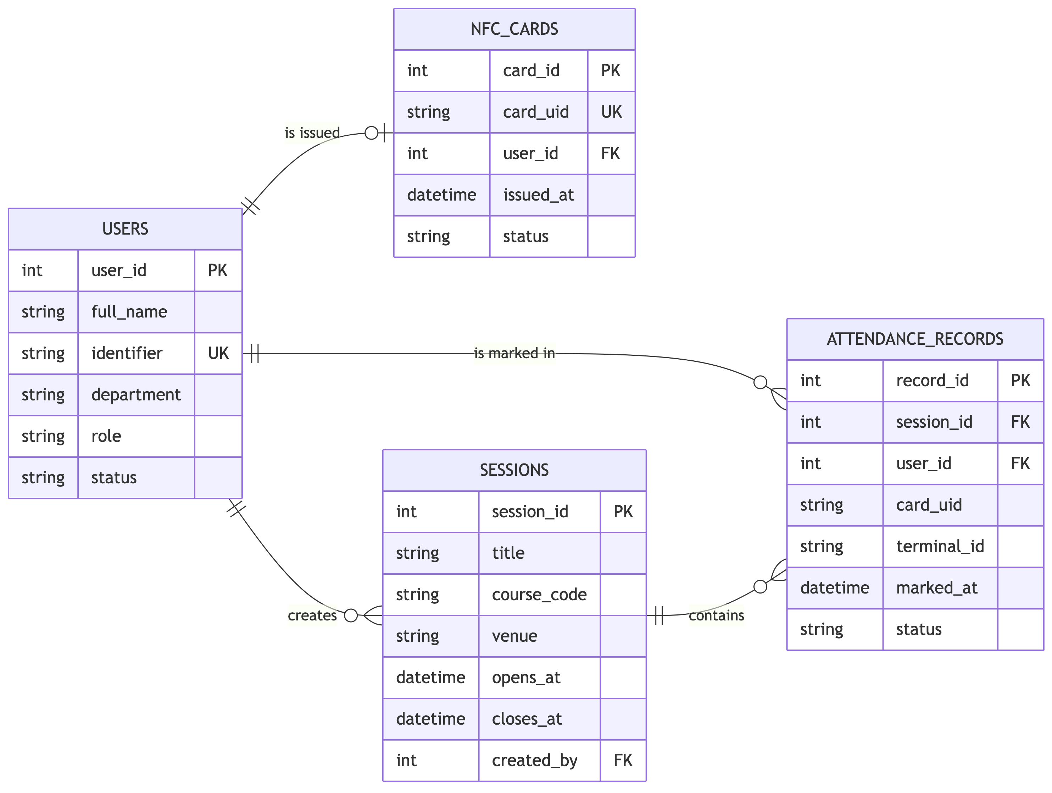
Figure 4.2: Entity-Relationship Diagram of the Database
A user is issued at most one active card and appears in many attendance records; a session contains many attendance records; and an administrator, who is a user with the administrator role, creates many sessions. Three decisions about this structure are worth stating.
The card is a separate table, not a column on the user. Keeping the card apart allows a card to be revoked and replaced without disturbing the user record, and allows the history of which card was held when to be preserved. A lost card is marked revoked rather than deleted, so the attendance it previously recorded remains explicable.
The attendance record stores the card UID that was actually presented, as well as the user. Storing only the user would make the record silently incorrect if the card were later reassigned, and would destroy the evidence needed to investigate a suspected cloning. Storing both means the record says who was credited and which physical card did it.
A unique constraint is placed on the pair (session_id, user_id). This is what makes the duplicate impossible rather than merely checked. Even if two taps were processed at the same instant by two terminals, the second insert would be refused by the database, so the rule cannot be defeated by timing.
4.5 Database Table Definition
Tables 4.2 to 4.5 define the four tables.
Table 4.2: Structure of the users Table
Field | Type | Description | Constraints
user_id | INT | Identifier of the user | Primary key, auto-increment
full_name | VARCHAR(100) | Full name of the user | Required
identifier | VARCHAR(30) | Matriculation or staff number | Required, unique
department | VARCHAR(80) | Department or unit | Required
role | ENUM | student, staff or administrator | Required, default student
password_hash | VARCHAR(100) | bcrypt hash; set for administrators only | Optional
status | ENUM | active or suspended | Required, default active
created_at | DATETIME | Time the record was created | Auto-generated

Table 4.3: Structure of the nfc_cards Table
Field | Type | Description | Constraints
card_id | INT | Identifier of the card record | Primary key, auto-increment
card_uid | VARCHAR(32) | Unique identifier read from the NFC card | Required, unique, indexed
user_id | INT | User to whom the card is issued | Foreign key to users
issued_at | DATETIME | Time the card was issued | Auto-generated
status | ENUM | active, revoked or lost | Required, default active

Table 4.4: Structure of the sessions Table
Field | Type | Description | Constraints
session_id | INT | Identifier of the session | Primary key, auto-increment
title | VARCHAR(120) | Title of the lecture or meeting | Required
course_code | VARCHAR(20) | Course or unit code | Optional
terminal_id | VARCHAR(20) | Terminal at which the session is open | Required
opens_at | DATETIME | Start of the window in which taps are accepted | Required
closes_at | DATETIME | End of that window | Required
created_by | INT | Administrator who opened the session | Foreign key to users

Table 4.5: Structure of the attendance_records Table
Field | Type | Description | Constraints
record_id | INT | Identifier of the record | Primary key, auto-increment
session_id | INT | Session in which the tap occurred | Foreign key, part of unique pair
user_id | INT | User credited with the attendance | Foreign key, part of unique pair
card_uid | VARCHAR(32) | The UID actually presented at the tap | Required
terminal_id | VARCHAR(20) | Terminal that reported the tap | Required
marked_at | DATETIME | Time the tap was accepted | Auto-generated
status | ENUM | present or late | Required, default present

4.6 Input and Output Formats
This section presents the design of the system's screens. Each figure shows the layout, the fields and the information to be presented; the values shown are illustrative. Figure 4.3 shows the sign-in screen, which is the entry point for the administrator.
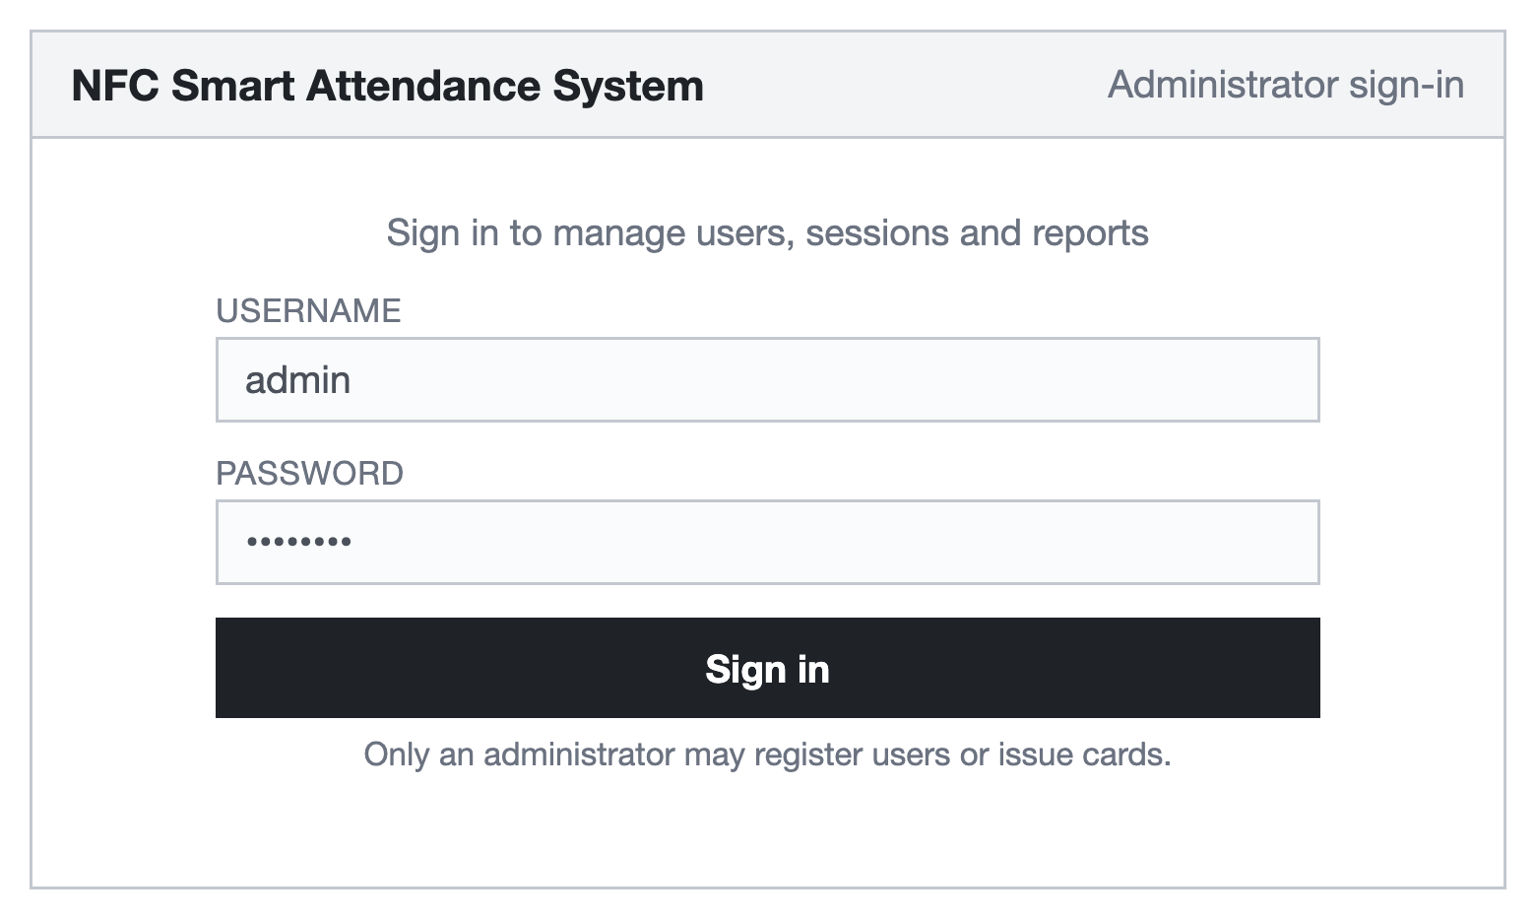
Figure 4.3: Interface Design for the Administrator Sign-In Screen
Only an administrator signs in. Ordinary users never authenticate to the system at all: their interaction is the tap, and the card is the credential. Figure 4.4 shows the dashboard presented after signing in.
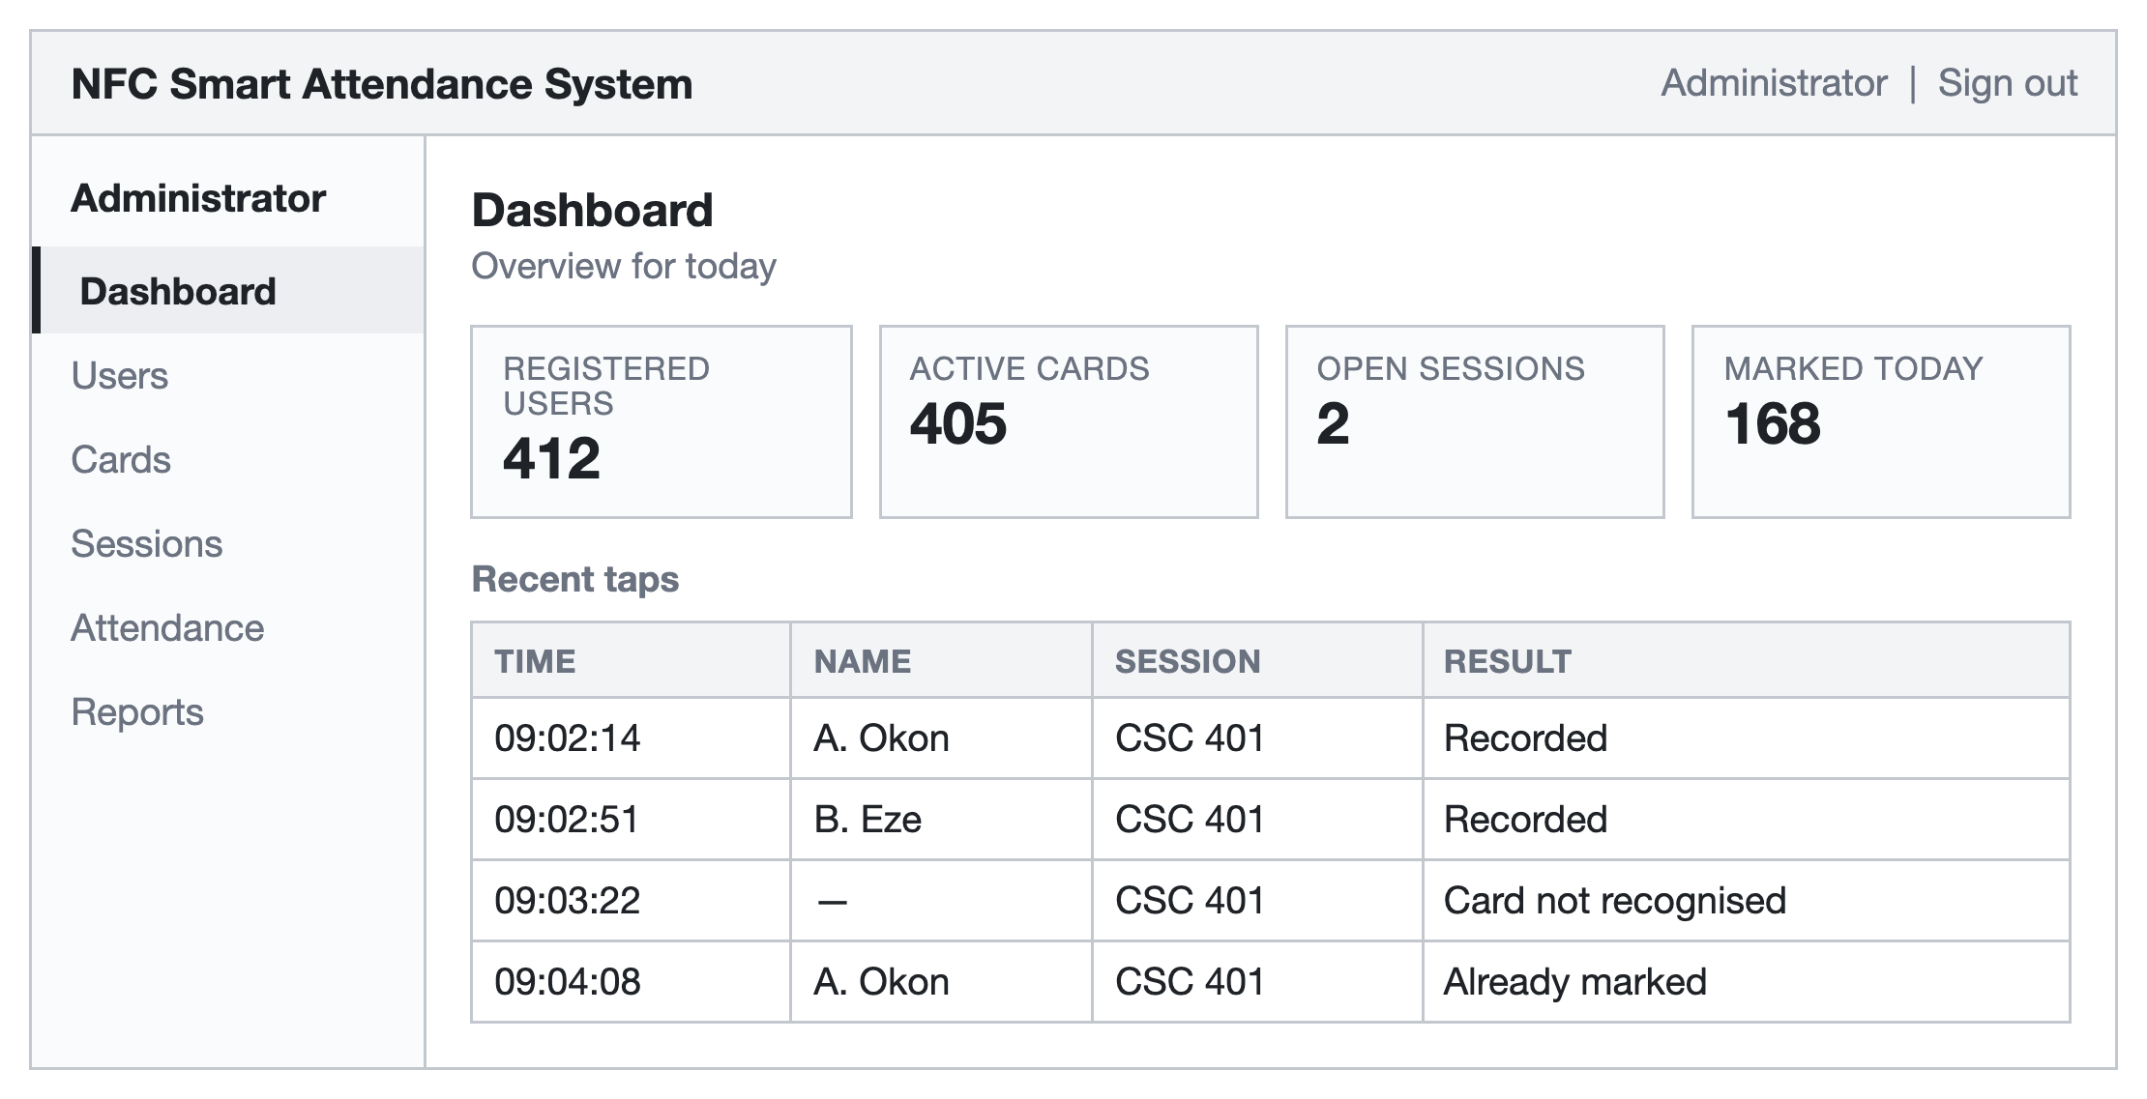
Figure 4.4: Interface Design for the Administrator Dashboard
The dashboard reports the size of the register and the activity of the day, and lists the most recent taps. The list deliberately includes refusals as well as acceptances, because a run of unrecognised cards at one terminal is the first visible sign of a problem. Figure 4.5 shows the screen on which a user is registered and a card issued.
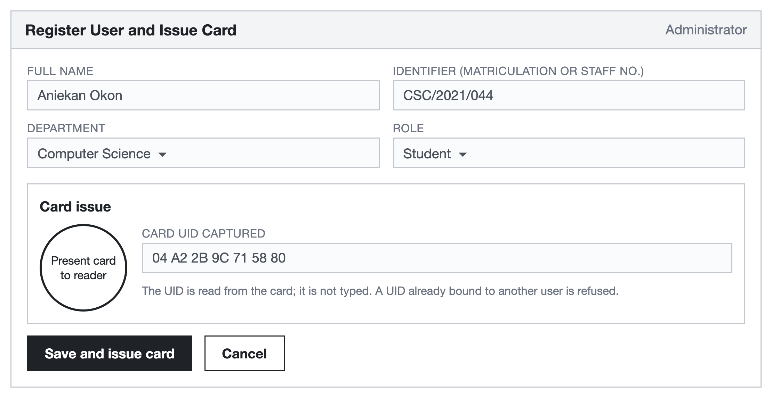
Figure 4.5: Interface Design for User Registration and Card Issue
The card's unique identifier is read from the card by presenting it to the reader; it is not typed. This matters, because a typed identifier could be invented, whereas a read identifier must have come from a card that was physically present. Figure 4.6 shows the attendance terminal and the two outcomes a tap may produce.
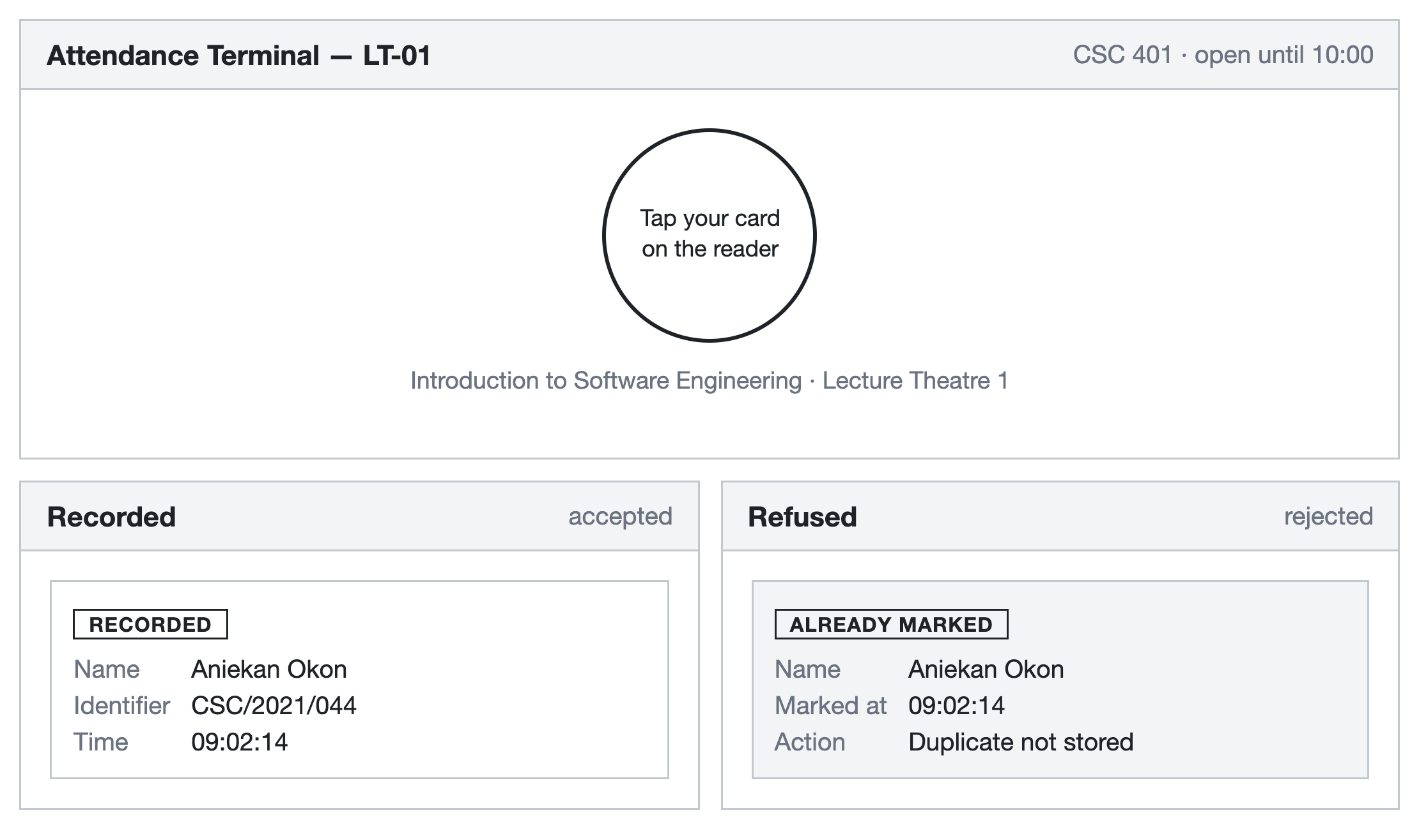
Figure 4.6: Interface Design for the Attendance Terminal and Its Two Outcomes
The terminal displays one instruction and nothing else, because it is operated by people walking past it rather than sitting at it. On an accepted tap it shows the name and the time recorded, which lets the user confirm that the right person was credited. On a refusal it shows the reason; the case illustrated is a second tap by someone already marked, which is refused rather than silently ignored so that the user does not keep trying. Figures 4.7 and 4.8 show session management and the attendance records.
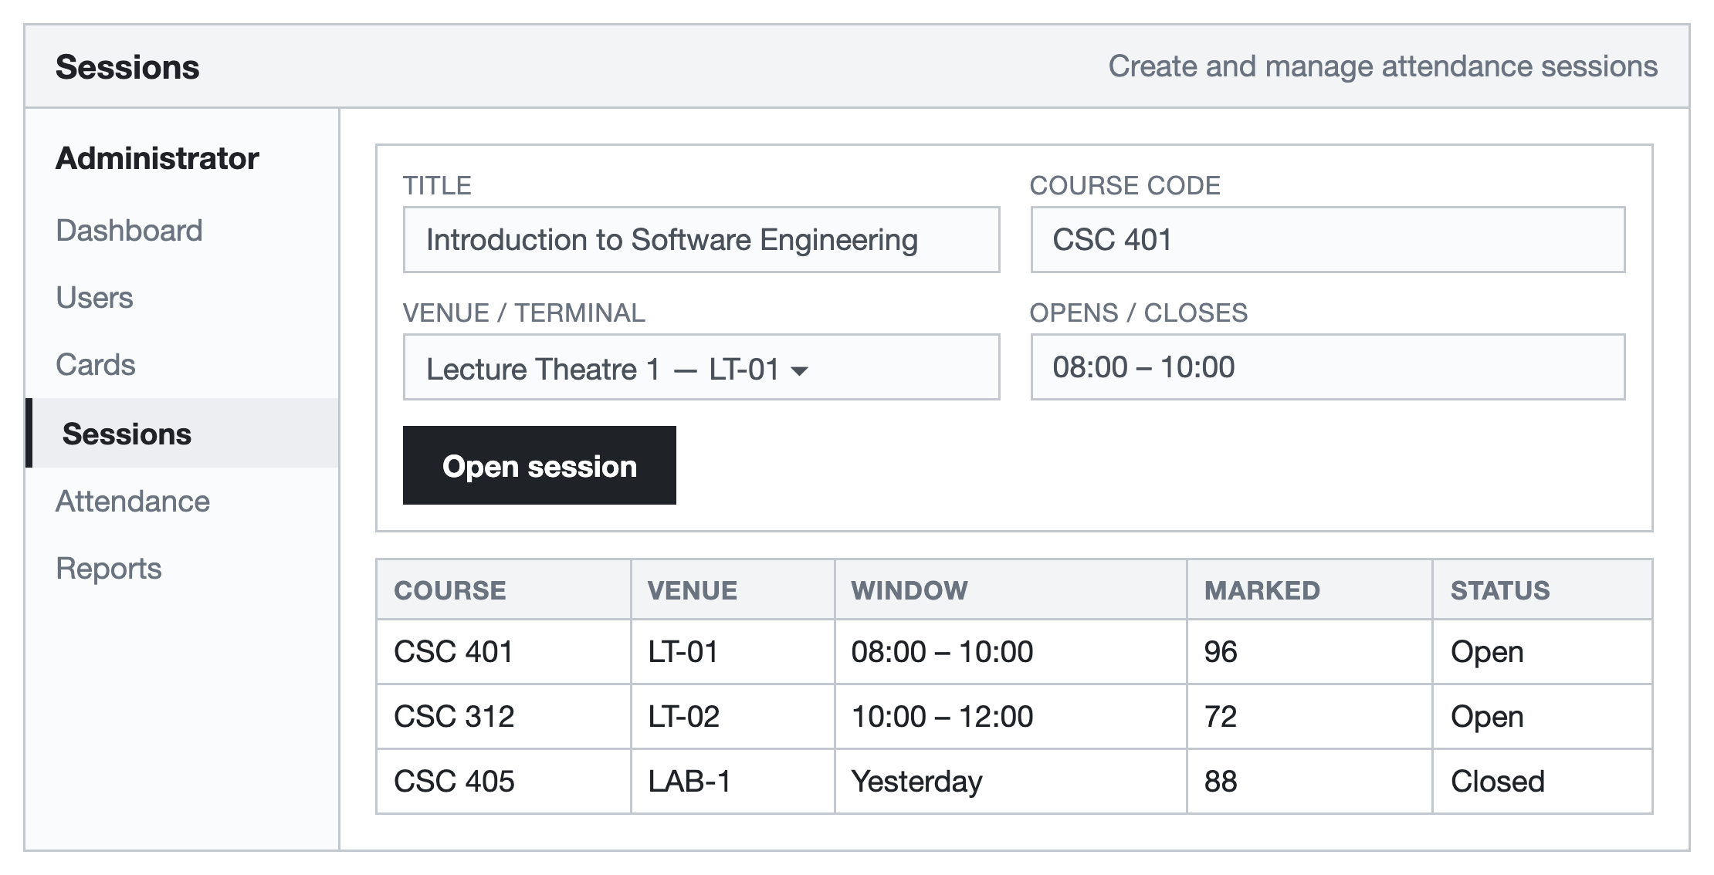
Figure 4.7: Interface Design for Session Management
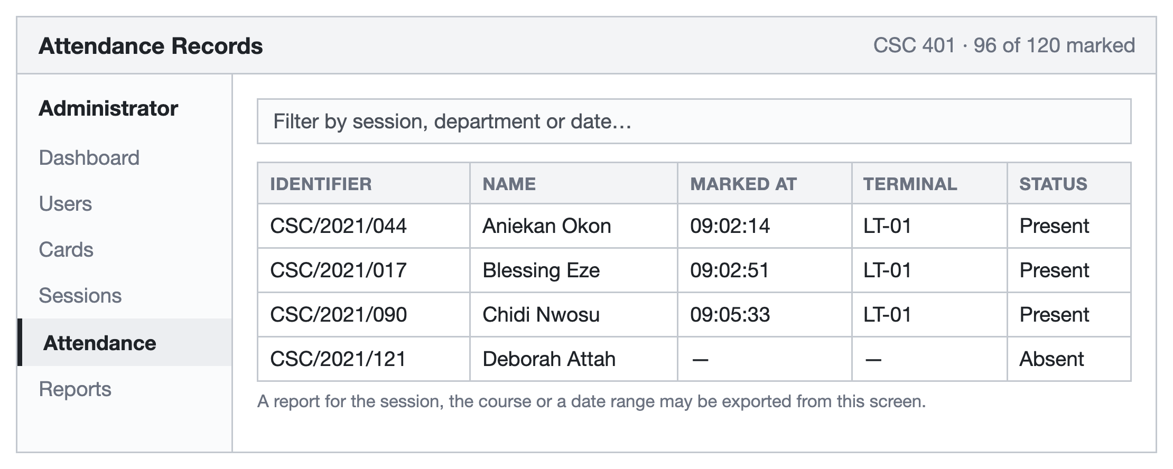
Figure 4.8: Interface Design for Attendance Records
A session fixes three things: the course, the terminal and the window of time. A tap counts only if it arrives at the right terminal inside the right window, which is what prevents a card being tapped at another venue or at another hour. The records screen lists those marked and those absent, and a report for a session, a course or a date range may be exported from it.
4.7 Program Algorithm
Two algorithms carry the system. The first issues a card; the second records an attendance.
Algorithm 4.1: Registration of a user and issue of an NFC card
INPUT : full name, identifier, department, role; a blank NFC card
OUTPUT : a user record and a card bound to it
1. Read the user details entered by the administrator.
2. IF any required field is empty THEN report and RETURN to step 1.
3. IF identifier already exists in users THEN
refuse the registration as a duplicate and STOP.
4. Insert the user record and obtain user_id.
5. Prompt for the card and read card_uid from the reader.
6. IF card_uid already exists in nfc_cards with status 'active' THEN
refuse the issue - a card belongs to one user - and STOP.
7. Insert (card_uid, user_id, status = 'active') into nfc_cards.
8. Print the card label and hand the card to the user.
9. STOP.

Algorithm 4.2: Recording an attendance from a tap
INPUT : card_uid read at terminal_id at time now
OUTPUT : an attendance record, or a stated refusal
1. session <- SELECT FROM sessions WHERE terminal_id = this terminal
AND now BETWEEN opens_at AND closes_at.
2. IF session is empty THEN
display 'No session is open' and STOP.
3. card <- SELECT FROM nfc_cards WHERE card_uid = uid AND status = 'active'.
4. IF card is empty THEN
write the attempt to the tap log as 'unrecognised'
display 'Card not recognised' and STOP.
5. user <- the user to whom the card is bound.
6. IF user.status is 'suspended' THEN
display 'Account suspended' and STOP.
7. TRY to insert (session_id, user_id, card_uid, terminal_id, now).
8. IF the insert is refused by the unique constraint THEN
display 'Already marked at' + the earlier time and STOP.
9. Display the user's name and the time recorded.
10. STOP.

Step 8 is the point at which the duplicate rule is enforced. The check is not performed by reading the table first and then deciding, because two taps arriving together could both read an empty result and both insert. The insert is attempted and the database's own constraint is allowed to refuse it, which is correct however the taps are timed.
4.7.1 The Limits of Identification by Card
Section 1.5 records that card cloning remains a threat, and the design should not pretend otherwise. A tap proves that a card bearing a particular identifier was present; it does not prove that the person holding it is the person to whom it was issued. Four features of the design reduce what an impersonator can achieve, and they are the reason the structure takes the form it does.
• A card is bound to exactly one user, so a borrowed card marks its owner present and not the borrower, and cannot mark both.
• Only one record per user per session can exist, so a person carrying two cards cannot be counted twice and cannot mark a second person with their own card.
• A tap counts only at the terminal and within the window the session fixes, so a card cannot be tapped elsewhere or at another hour.
• Every tap is logged, including refusals, so repeated unrecognised cards or a pattern of taps in quick succession at one terminal can be examined after the fact.
What these measures do not do is establish the holder's identity, and no arrangement built on the card alone can. Where that assurance is required, the design provides for a short personal number to be requested at the terminal after the tap for nominated sessions, which adds a second factor without slowing the ordinary case. This is recommended in Section 5.3 rather than assumed here, because it trades speed for assurance and the institution should choose.
4.8 Program Flowchart
The algorithms of Section 4.7 are presented here in flowchart form. In both charts the answer Yes continues the main path and the answer No branches to a refusal.
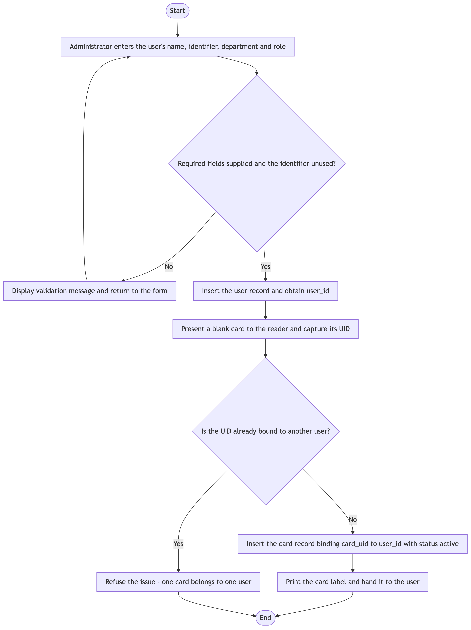
Figure 4.9: Flowchart of User Registration and Card Issue
Figure 4.9 shows that the card is issued only after the user record exists, so a card can never be bound to a user who was not stored. Figure 4.10 shows the four distinct refusals a tap may meet: no open session, an unrecognised card, a suspended account, and a duplicate.
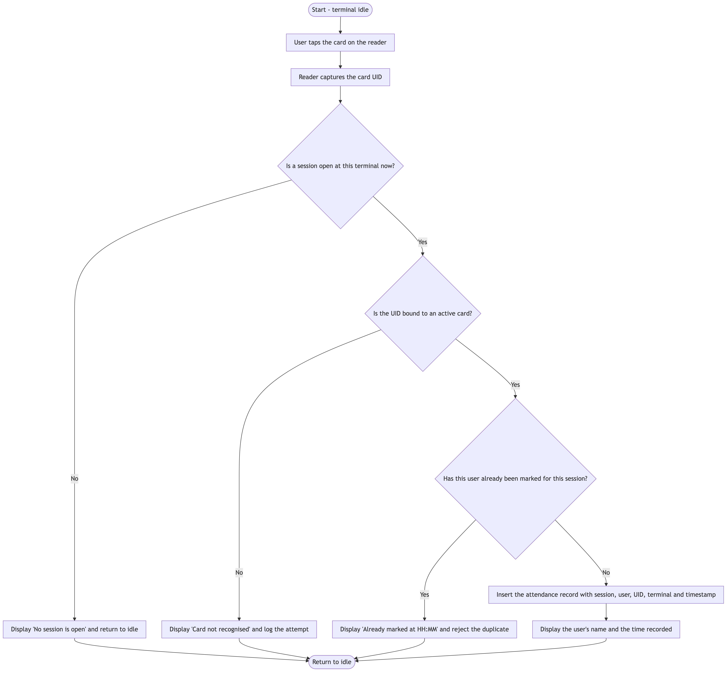
Figure 4.10: Flowchart of the Attendance Marking Process
Figure 4.11 presents the same process as an exchange between the parties involved, which makes clear how little is decided at the terminal itself.
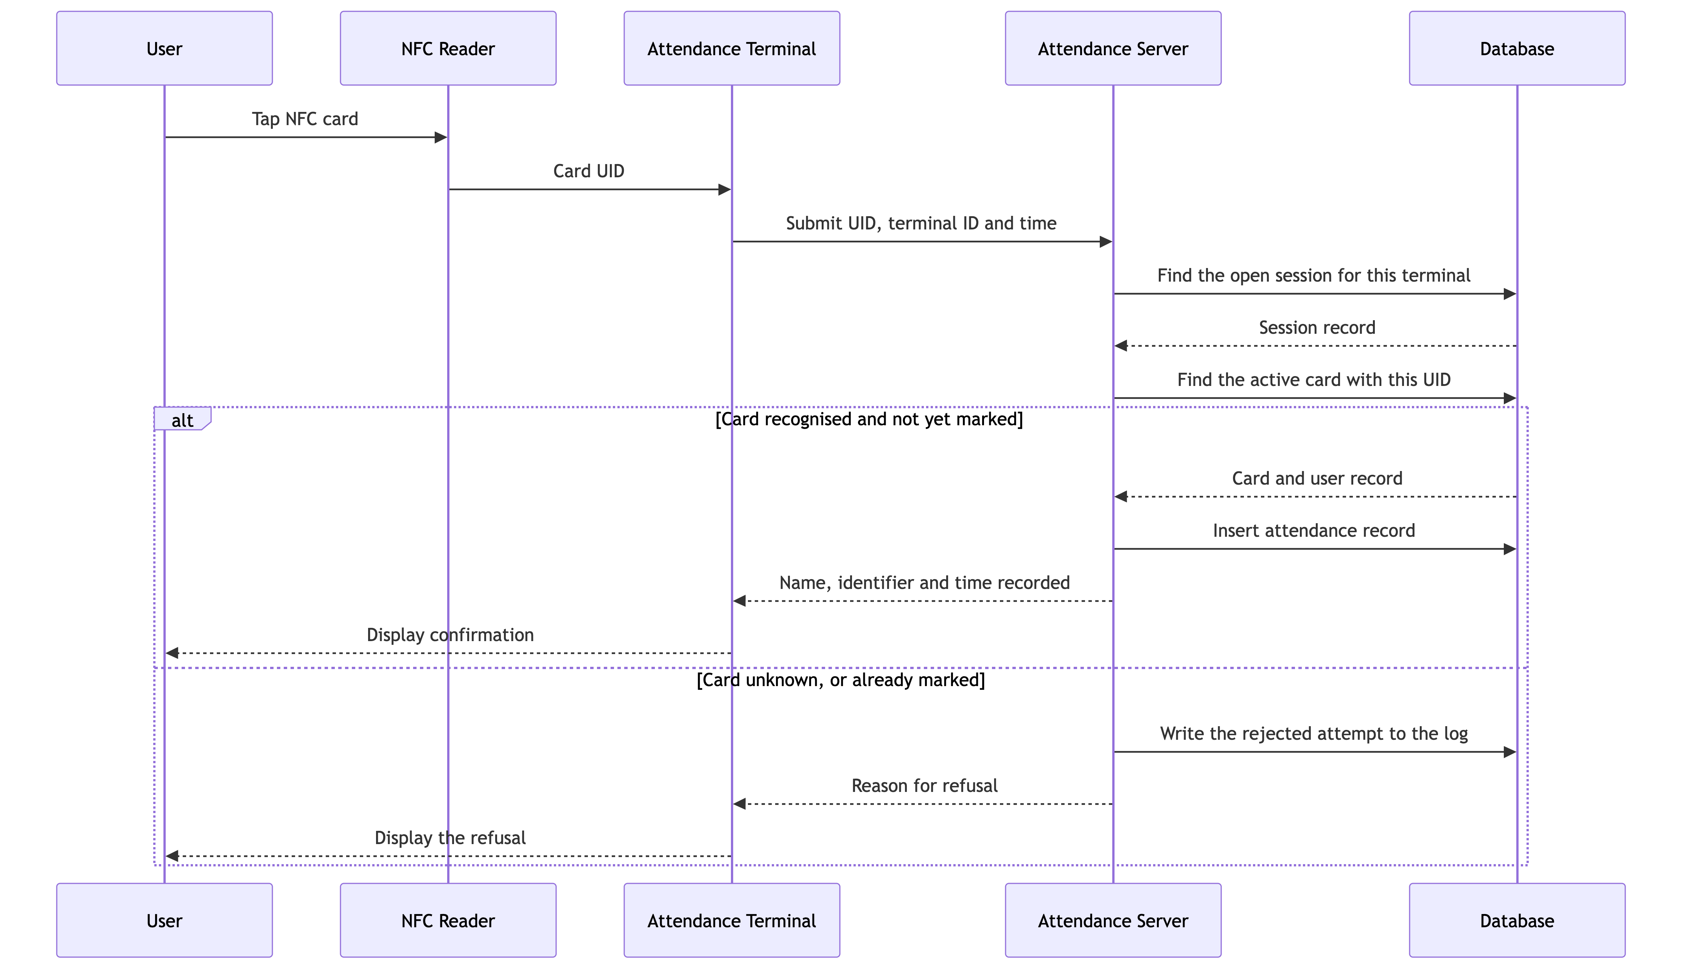
Figure 4.11: Sequence Diagram for a Card Tap
4.9 Hardware Requirements
NFC cards or tags. One card per registered user, operating at 13.56 MHz and conforming to ISO/IEC 14443 (ISO/IEC, 2018), which is the family of contactless cards that NFC readers address.
NFC reader. One contactless reader per attendance terminal, connected to the terminal by USB and capable of returning the unique identifier of a presented card.
Attendance terminal. A computer or single-board computer at each venue with a display sufficient to show one line of confirmation, a USB port for the reader, and a network connection to the server.
Server. Any host able to run the application and the database. At the scale of a single institution a modest virtual server with 4 GB of memory is sufficient; the load is one short transaction per tap.
Administrator workstation. Any computer with a current browser; no installation is required, since the console is reached over the network.
4.10 Software Requirements
Server. An operating system capable of running Python 3.10 or later, a MySQL database server, and a web server to front the application.
Attendance terminal. Python 3.10 or later with the reader library and its driver, and a browser or a simple windowed program to present the display of Figure 4.6.
Administrator workstation. A current version of any mainstream browser, with cookies permitted for the site since the administrator's session is carried in a cookie.
The external libraries and services the system depends upon are listed in Table 4.6. All are open-source, so the system carries no licence cost; the expenditure is in the readers and the cards, which is the cost noted in Section 1.5.
Table 4.6: Third-Party Libraries and Services
Library or service | Purpose
Flask | Web framework for the console and the terminal endpoint
SQLAlchemy | Database access with parameterised statements
PyMySQL | MySQL driver
pyscard | Access to PC/SC contactless readers to obtain the card UID
nfcpy | Alternative reader access where the device is not PC/SC
bcrypt | Hashing of administrator passwords
Jinja2 | Template rendering for the console screens
openpyxl | Export of attendance reports to a spreadsheet

4.11 Documentation
Three forms of documentation accompany the system.
A user guide is to be produced for the two audiences the system serves. For the administrator it covers signing in, registering a user, issuing and revoking a card, opening and closing a session, and exporting a report. For the person who taps, it is a single page: present the card to the reader, wait for your name, and report to the administrator if the card is refused.
The program listings in Appendix A document the implementation. They give the schema in which the rules are expressed, the procedure that issues a card, the handler that records a tap, and the loop that reads the reader. The test plan in Appendix B states what is to be exercised against the built system and the result each case is expected to produce.
The design is self-documenting in one respect worth stating. The duplicate rule is declared once, as a unique constraint in the schema, so what the system refuses can be read from the table definition without tracing the program that acts on it.

CHAPTER FIVE
SUMMARY, CONCLUSION AND RECOMMENDATION
5.1 Summary
This study set out to design a smart attendance system using Near Field Communication, in answer to the weaknesses of manual attendance recording identified in Chapter One. Chapter Two reviewed attendance management, smart attendance systems and NFC, and established that NFC's very short range makes it better suited to attendance than the longer-range RFID, because a tap must be deliberate. Chapter Three analysed the existing manual arrangement, set out its weaknesses, and proposed the NFC-based alternative.
Chapter Four presented the design. The system was designed in three tiers with every rule held on the server, over a database of four tables holding users, issued cards, sessions and attendance records. Two algorithms were specified, one to register a user and bind a card and one to record an attendance from a tap, and both were expressed as flowcharts. Interface designs were produced for the sign-in, dashboard, registration, terminal, session and records screens, and the hardware and software needed to build the system were stated.
5.2 Conclusion
The study concludes that an NFC-based attendance system addresses most of the weaknesses of the manual arrangement directly. A tap takes about a second, so the time lost to roll-calling is recovered. The record is created by the system rather than written by hand, so omission, duplication and misreading do not arise. The record is stored in a database rather than on paper, so it cannot be mislaid and can be searched. Reports that were compiled by hand become a query.
On impersonation, which Section 1.2 names as a principal problem, the conclusion must be more careful. The design makes proxy attendance harder in specific and stateable ways: a card marks only its owner, a user can be marked only once in a session, and a tap counts only at the right terminal within the right window. It does not make proxy attendance impossible, because a card can be handed to someone else and a card identifier can in principle be cloned. The honest claim is that the system removes casual impersonation and leaves a record by which the deliberate kind may be investigated, not that it eliminates it.
It should also be stated plainly that the system is presented here as a design. It has not been built or deployed, and the results in Appendix B are expected rather than measured. The objective of Section 1.3 concerning evaluation of performance and reliability is therefore met by specifying how the system is to be evaluated, and not by reporting an evaluation.
5.3 Recommendation
The following recommendations are made:
• The institution should issue cards centrally and record the issue, so that every active card is traceable to the person who received it.
• Where a session carries weight, such as an examination or a session with an attendance requirement, a short personal number should be requested at the terminal after the tap. This adds the second factor the card alone cannot provide, at the cost of a few seconds.
• Readers that expose only the card's identifier should be preferred to arrangements that write data onto the card, since nothing on the card then needs to be trusted.
• The tap log, including refusals, should be retained and reviewed, because a pattern of unrecognised cards or of rapid successive taps at one terminal is the evidence that impersonation is being attempted.
• A procedure should be published for reporting and revoking a lost card on the day it is lost, since a card in circulation that is no longer held by its owner is the system's principal weakness.
• The system should be built and evaluated against the plan in Appendix B before it is relied upon, and the expected results there replaced by measured ones.

REFERENCES
Adeyemo and Adebayo (2018). Manual attendance systems in academic institutions: inefficiency, falsification and the loss of records. [Publication details to be inserted.]
Alade, Ojo and Balogun (2021). Integrating NFC attendance systems with database management systems for centralised, real-time tracking and reporting. [Publication details to be inserted.]
Elmasri, R., & Navathe, S. B. (2016). Fundamentals of database systems (7th ed.). Boston: Pearson.
International Organization for Standardization / International Electrotechnical Commission (2018). ISO/IEC 14443 — Cards and security devices for personal identification: contactless proximity objects. Geneva: ISO.
Kaur and Singh (2020). An NFC-based smart attendance system for educational institutions. [Publication details to be inserted.]
Patel and Shah (2019). An RFID-based attendance system: speed, automation and the risk of proxy attendance. [Publication details to be inserted.]
Pressman, R. S., & Maxim, B. R. (2015). Software engineering: A practitioner’s approach (8th ed.). New York: McGraw-Hill Education.
Want and others (2015). Near Field Communication as a short-range subset of RFID for secure identification. [Publication details to be inserted.]
Zhang and others (2022). A mobile NFC attendance system integrated with cloud storage. [Publication details to be inserted.]
APPENDIX A
PROGRAM LISTINGS
The listings below give the parts of the implementation in which the system's rules are expressed. Presentation templates and configuration are omitted.
A.1 Database schema
CREATE TABLE users (
user_id INT AUTO_INCREMENT PRIMARY KEY,
full_name VARCHAR(100) NOT NULL,
identifier VARCHAR(30) NOT NULL UNIQUE,
department VARCHAR(80) NOT NULL,
role ENUM('student','staff','administrator') DEFAULT 'student',
password_hash VARCHAR(100) NULL,
status ENUM('active','suspended') DEFAULT 'active',
created_at DATETIME DEFAULT CURRENT_TIMESTAMP);

CREATE TABLE nfc_cards (
card_id INT AUTO_INCREMENT PRIMARY KEY,
card_uid VARCHAR(32) NOT NULL UNIQUE,
user_id INT NOT NULL,
issued_at DATETIME DEFAULT CURRENT_TIMESTAMP,
status ENUM('active','revoked','lost') DEFAULT 'active',
FOREIGN KEY (user_id) REFERENCES users(user_id));

CREATE TABLE sessions (
session_id INT AUTO_INCREMENT PRIMARY KEY,
title VARCHAR(120) NOT NULL,
course_code VARCHAR(20),
terminal_id VARCHAR(20) NOT NULL,
opens_at DATETIME NOT NULL,
closes_at DATETIME NOT NULL,
created_by INT, FOREIGN KEY (created_by) REFERENCES users(user_id));

CREATE TABLE attendance_records (
record_id INT AUTO_INCREMENT PRIMARY KEY,
session_id INT NOT NULL,
user_id INT NOT NULL,
card_uid VARCHAR(32) NOT NULL,
terminal_id VARCHAR(20) NOT NULL,
marked_at DATETIME DEFAULT CURRENT_TIMESTAMP,
status ENUM('present','late') DEFAULT 'present',
FOREIGN KEY (session_id) REFERENCES sessions(session_id),
FOREIGN KEY (user_id) REFERENCES users(user_id),
-- the duplicate rule, enforced by the database itself
UNIQUE KEY one_mark_per_session (session_id, user_id));

A.2 Issuing a card
def issue_card(db, user_id, card_uid):
existing = db.execute(
'SELECT user_id FROM nfc_cards '
'WHERE card_uid = %s AND status = %s',
(card_uid, 'active')).fetchone()
if existing is not None:
raise CardAlreadyIssued(
'This card is already issued to another user.')

db.execute('INSERT INTO nfc_cards (card_uid, user_id) '
'VALUES (%s, %s)', (card_uid, user_id))
db.commit()

A.3 Recording a tap
from datetime import datetime
import pymysql

def record_tap(db, card_uid, terminal_id):
now = datetime.now()

session = db.execute(
'SELECT session_id FROM sessions WHERE terminal_id = %s '
'AND %s BETWEEN opens_at AND closes_at',
(terminal_id, now)).fetchone()
if session is None:
return {'ok': False, 'reason': 'No session is open'}

card = db.execute(
'SELECT c.user_id, u.full_name, u.status '
'FROM nfc_cards c JOIN users u ON u.user_id = c.user_id '
'WHERE c.card_uid = %s AND c.status = %s',
(card_uid, 'active')).fetchone()
if card is None:
log_attempt(db, card_uid, terminal_id, 'unrecognised')
return {'ok': False, 'reason': 'Card not recognised'}

if card['status'] == 'suspended':
return {'ok': False, 'reason': 'Account suspended'}

try:
db.execute(
'INSERT INTO attendance_records '
'(session_id, user_id, card_uid, terminal_id, marked_at) '
'VALUES (%s, %s, %s, %s, %s)',
(session['session_id'], card['user_id'],
card_uid, terminal_id, now))
db.commit()
except pymysql.err.IntegrityError:
# the unique key refused it: this user is already marked
db.rollback()
earlier = db.execute(
'SELECT marked_at FROM attendance_records '
'WHERE session_id = %s AND user_id = %s',
(session['session_id'], card['user_id'])).fetchone()
return {'ok': False,
'reason': 'Already marked at %s'
% earlier['marked_at'].strftime('%H:%M')}

return {'ok': True, 'name': card['full_name'],
'time': now.strftime('%H:%M:%S')}

A.4 Reading the card at the terminal
from smartcard.System import readers
from smartcard.util import toHexString

GET_UID = [0xFF, 0xCA, 0x00, 0x00, 0x00] # PC/SC: return the card UID

def read_uid(connection):
data, sw1, sw2 = connection.transmit(GET_UID)
if (sw1, sw2) != (0x90, 0x00):
return None # no card, or a read error
return toHexString(data).replace(' ', '')

def terminal_loop(terminal_id):
reader = readers()[0]
while True:
connection = reader.createConnection()
try:
connection.connect()
uid = read_uid(connection)
if uid:
result = post_to_server(uid, terminal_id)
display(result)
except Exception:
pass # no card present; keep polling
finally:
sleep(0.4)

APPENDIX B
TEST PLAN AND EXPECTED RESULTS
Pressman and Maxim (2015) hold that testing should be planned to reveal defects rather than to demonstrate that a system works. The cases below are accordingly drawn from the branches of Algorithms 4.1 and 4.2, so that every path through the two procedures is exercised at least once. They state the result each case is expected to produce when the system has been built; they are not measurements, and the system has not been deployed.
Table B.1: Test Plan and Expected Results
ID | Test case | Expected result
T-01 | Register a user with all fields supplied. | The user record is stored and a user_id assigned.
T-02 | Register a user whose identifier already exists. | Registration is refused as a duplicate; no second record is created.
T-03 | Issue a blank card to a registered user. | The UID is read from the card and bound to that user with status active.
T-04 | Issue a card whose UID is already active for another user. | The issue is refused; the card remains bound to its first owner.
T-05 | Tap a valid card inside an open session at the right terminal. | Attendance is recorded; the terminal shows the user's name and the time.
T-06 | Tap the same card a second time in the same session. | Refused with 'Already marked at'; the stored record is unchanged.
T-07 | Tap a card that has never been issued. | Refused with 'Card not recognised'; the attempt is written to the tap log.
T-08 | Tap a card that has been revoked as lost. | Refused; a revoked card cannot mark attendance.
T-09 | Tap a valid card when no session is open at that terminal. | Refused with 'No session is open'; nothing is stored.
T-10 | Tap a valid card at a terminal other than the session's terminal. | Refused; the tap counts only at the terminal the session names.
T-11 | Tap a valid card after the session's closing time. | Refused; the window has closed.
T-12 | Tap a card belonging to a suspended user. | Refused with 'Account suspended'.
T-13 | Submit two taps for the same user at the same instant from two terminals. | Exactly one record exists; the second is refused by the unique constraint.
T-14 | Export a report for a closed session. | Every registered user appears, marked present or absent, with times for those present.

